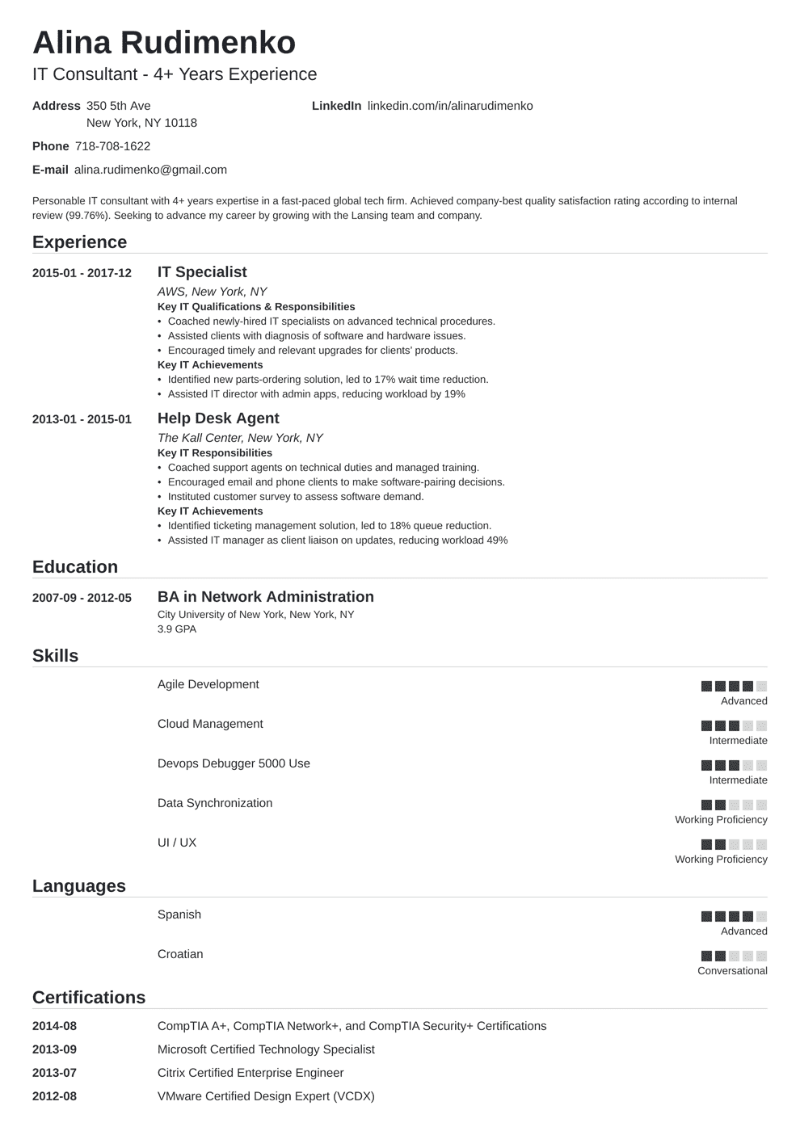
Alina Rudimenko
IT Consultant - 4+ Years Experience
Address 350 5th Ave
LinkedIn linkedin.com/in/alinarudimenko
New York, NY 10118
Phone 718-708-1622
E-mail alina.rudimenko@gmail.com
Personable IT consultant with 4+ years expertise in a fast-paced global tech firm. Achieved company-best quality satisfaction rating according to internal review (99.76%). Seeking to advance my career by growing with the Lansing team and company.
Experience
2015-01-2017-12 IT Specialist
2013-01-2015-01
Education
2007-09-2012-05
AWS, New York, NY
Key IT Qualifications & Responsibilities
• Coached newly-hired IT specialists on advanced technical procedures.
• Assisted clients with diagnosis of software and hardware issues.
• Encouraged timely and relevant upgrades for clients' products.
Key IT Achievements
• Identified new parts-ordering solution, led to 17% wait time reduction.
• Assisted IT director with admin apps, reducing workload by 19%
Help Desk Agent
The Kall Center, New York, NY
Key IT Responsibilities
• Coached support agents on technical duties and managed training.
• Encouraged email and phone clients to make software-pairing decisions.
⚫ Instituted customer survey to assess software demand.
Key IT Achievements
• Identified ticketing management solution, led to 18% queue reduction.
• Assisted IT manager as client liaison on updates, reducing workload 49%
BA in Network Administration
City University of New York, New York, NY 3.9 GPA
Skills
Agile Development
Languages
Cloud Management
Devops Debugger 5000 Use
Data Synchronization
UI / UX
Spanish
Croatian
Certifications
2014-08
2013-09
CompTIA A+, CompTIA Network+, and CompTIA Security+ Certifications
Microsoft Certified Technology Specialist
2013-07
Citrix Certified Enterprise Engineer
2012-08
VMware Certified Design Expert (VCDX)
Advanced
Intermediate
Intermediate
Working Proficiency
Working Proficiency
Advanced
Conversational

